

***Module-4***

Data Visualizations

# Different types of Charts

# Tableau - Your Visual Interface to Data

1. **Bar Chart**

Bar graphs are used to make comparison between different groups, we can also use it to track changes over time. When we try to measure changes over time, bar graphs are best when those changes are larger.

**Example:** A delivery service center assures that deliveries will be done within a specified time. They now want to determine how well they are doing during peak and non-peak hours.

The dataset uses two categorical variables, each having two values, which produces four possible combinations:

Delivery time

* Peak
* Off-peak

Delivery status

* On time
* Late

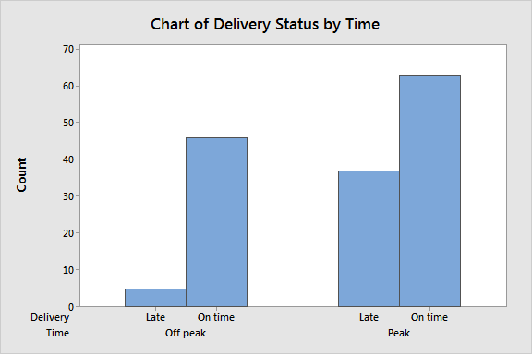

1. **Histogram**

Histograms display the distribution of continuous data. We can use these graphs, when we have continuous measurements and want to find distribution of values or look for outliers.

These graphs take continuous measurements and place them into ranges of values known as bins.  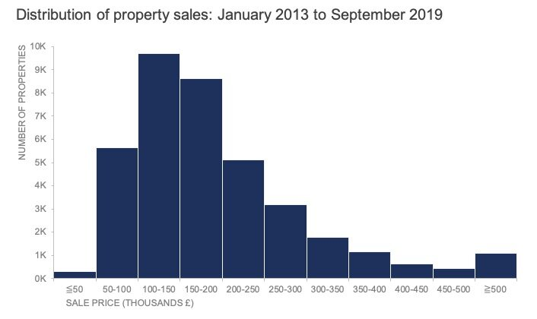

1. **­Pie Chart**

Pie charts are used to compare the sizes of categories to the entire dataset. They do not show changes over time.

**Example:** showing percentages of different jobs in an industry.

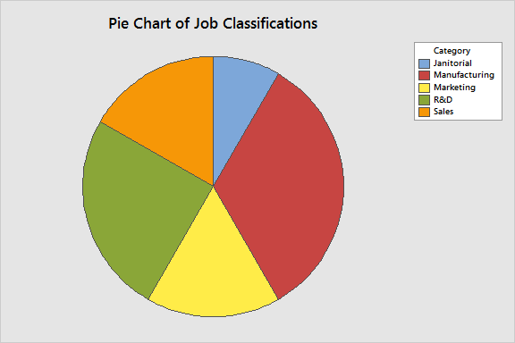

1. **Donut Chart**

A donut chart is almost identical to a pie chart, but the center is cut out that’s why it is known as “Donut”.

These are also used to show proportions of categories that make up the whole.

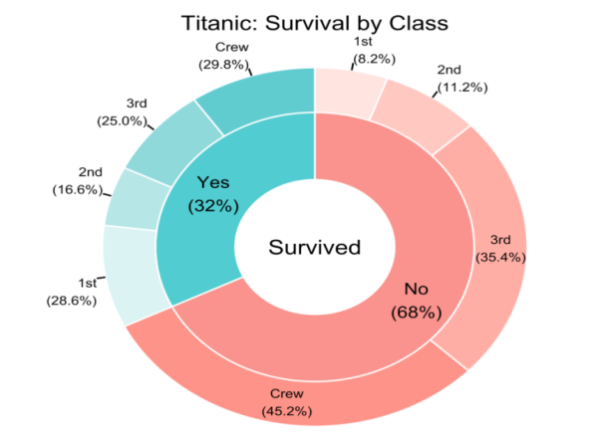

**Difference between Pie and Donut chart:**

* The hole in Donut chart can be used to highlight certain metrics like sum of all the sectors of the feature. Hence allows the doughnut chart to represent a little more data than a pie chart.
* A doughnut chart can contain two different data series in form of two concentric doughnuts, which is not possible in case of a pie chart.
* If there are more than 4 or 5 categories, prefer pie chart. For 2 and 4 categories, go with donut chart.

1. **Line Chart**

Line graphs are used to track changes over short and long periods of time. For smaller changes, line graphs are better to use than bar graphs.

Line graphs can also be used to compare changes over the same period of time for more than one group.

**Example:** A finance company wants to plot changes in cash amount that company has on hand over time.

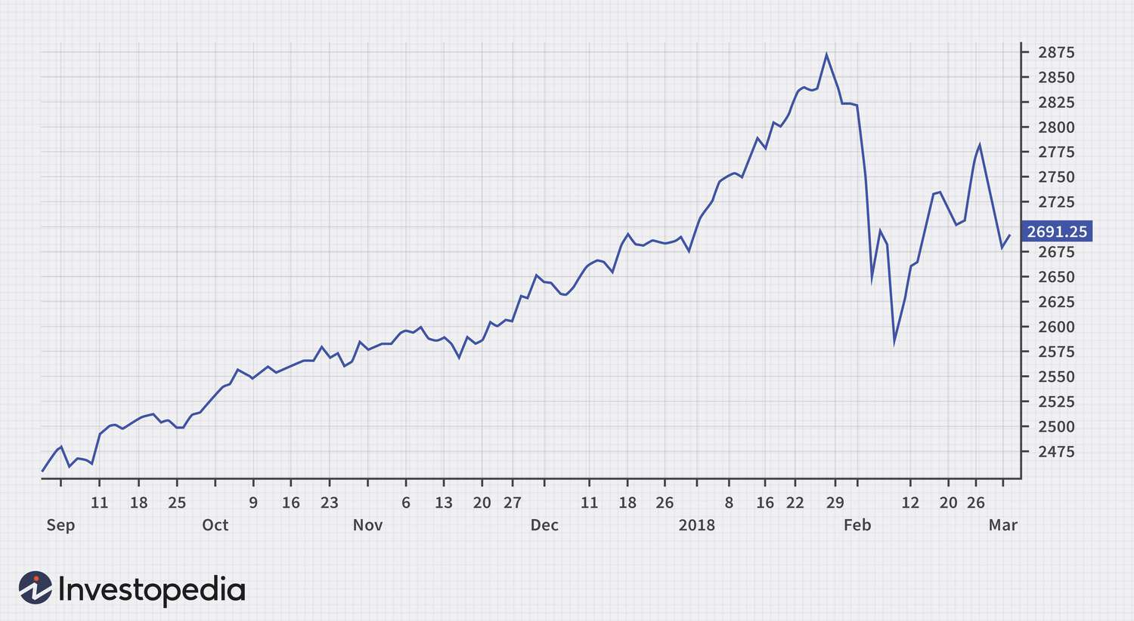

1. **Area Chart**

An area chart combines line and bar chart to show how numerical values of one or more groups change over the progression of a second variable, mostly time.

An area chart is different from a line chart by the addition of shading between lines and a baseline.

**Example:** Changes in number of dogs and cats in rescue over time from 2009 to 2019.

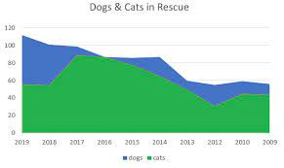

1. **Scatter Plot**

Scatter-plot is used to determine whether there exists a relationship exists between two continuous variables.

Scatter plots are used to:

* Examine the correlation between two variables.
* Check the outliers
* Create a time series plot.
* Evaluate the fit of a regression model.

**Example:** A nutritionist wants to find out the relation between BMI and percent of fat.

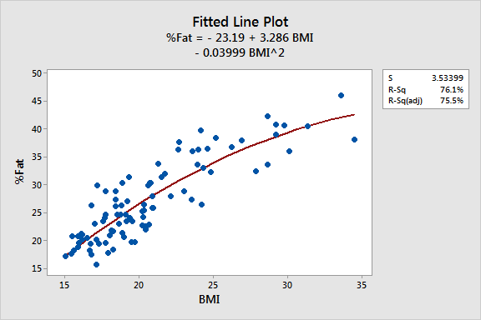 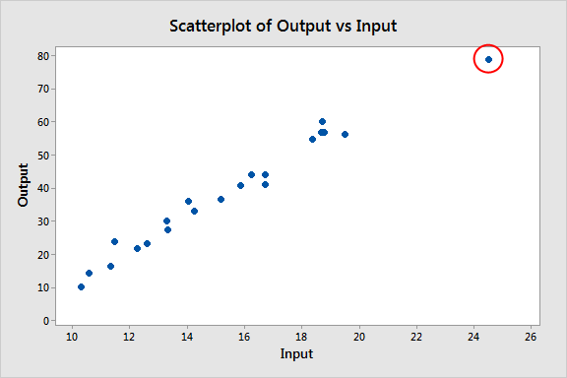

1. **Funnel Chart**

Funnel charts are used to illustrate stages in a process (usually sales processes). They can also be used to show anything that’s decreasing in size.

We can use this chart to show:

* An order fulfillment process.
* A sales process from start to finish.
* Flow of information from top secret to unclassified.
* Knowledge areas from general knowledge to expert knowledge.

**Example:** Suppose we want to find percentage of people in different stages during online shopping.

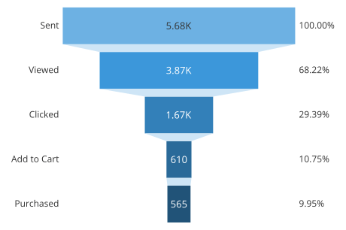

1. **Tree Maps**

* Tree chart is used to visualize data as parts of a whole inside a category.
* The tree-map can be composed of nested rectangles in case we have hierarchical categories.
* For hierarchical categories in data, a tree chart does a good job.

**Example:** We want to visualize fraction of storage amount for categories like technology, office supplies, furniture etc. having sub categories.

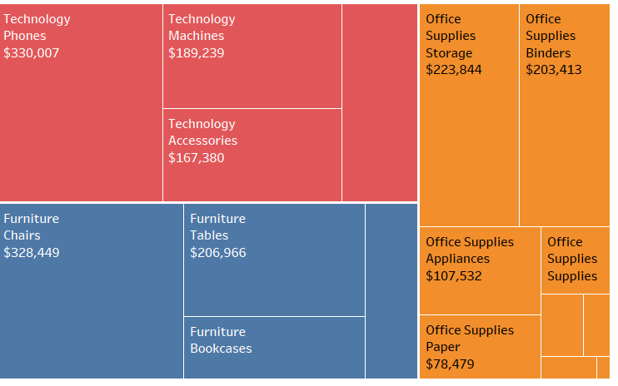

1. **Geospatial Map**

Focus on the relationship between data and its physical location to create insights from it.

Geospatial visualizations highlight the physical connection between data points.

They help identify problems, track change, understand trends, and perform forecasting related to specific places and times.

**Example:** Performance of a website by number of visits on that website at different locations on map.

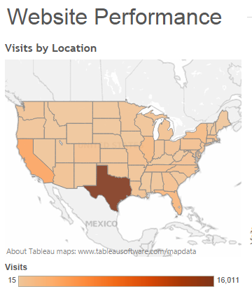

1. **Choropleth Map**

Choropleth maps are used to pair data with its geographic location.

They only work when the data set includes location-specific data such as the zip code, county, state, or even country.

**Examples:** Political information is mapped out geographically. Political campaigns use it to strategize, and the media uses it for visual reporting.

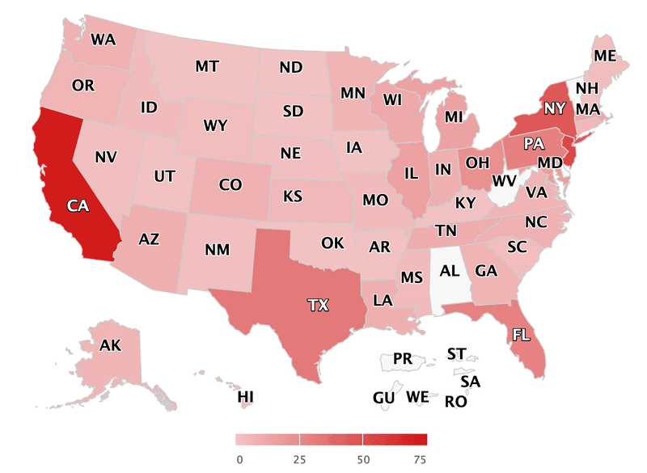

1. **Gauge**

Gauge charts are known as a speedometer chart or a dial chart.

A gauge chart is most commonly used visual tools to represent progressive values, targets or deadlines.

**Examples:** Gauge charts are extensively used in project management to define deadlines, modules, and related details.

We can also use them for competitive analysis or to compare the change of different entities over a common parameter.

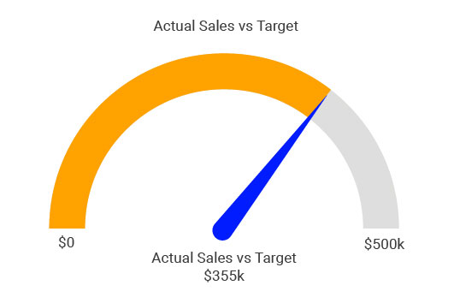

1. **Waterfall Chart**

A waterfall chart shows a running total as values are added or subtracted. It's useful for understanding how an initial value (for example, net income) is affected by a series of positive and negative changes.

Waterfall charts are used:

* When you have changes for the measure across time or across different categories.
* To audit the major changes contributing to the total value.

**Examples:**

* To plot your company's annual profit by showing various sources of revenue and arrive at the total profit (or loss).
* To illustrate the beginning and the ending headcount for your company in a year.
* To visualize how much money you make and spend each month, and the running balance for your account.

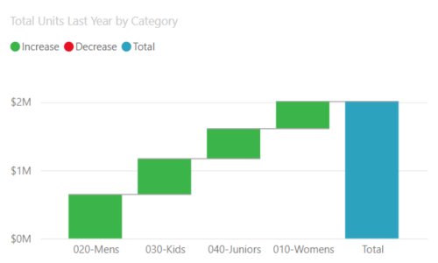

1. **Heatmap**

Heat-maps are used to show relationships between two variables, one plotted on each axis. By observing how cell colors change across each axis, we can observe if there are any patterns in value for one or both variables.

A heatmap shows relation of each feature with another.

